Working from Home: A Brief Guide for Employees
To help reduce the spread of COVID-19, many employers have asked employees to work remotely.

There are many benefits to working from home, setting your alarm back an hour, no time wasted sat in traffic and no waiting for delayed trains. Your productivity is likely to increase and you should notice improvements in your overall work-life balance. Whilst you are hopefully enjoying the benefits of working from home, it is possible that you have also noticed some drawbacks.

In this guide, we will look at the impact that working from home may have on both your physical and mental health and offer practical guidance on what you can do to minimise the potential drawbacks, allowing you to make the most of the benefits.

The Physical Impact of Working from Home

If you are new to remote working, you might not have a suitable workstation set-up at home. Many workers will now be working from laptop computers on whatever surface is available, even from the sofa. Over time this can lead to aches and pains, and potentially long-lasting musculoskeletal problems.

Working on computers with poor posture (left) can lead to problems in your neck, shoulders, back, arms, wrists and hands, as well as fatigue and eye strain. It is therefore important that you try to maintain a good posture when working at a computer for prolonged periods.

Even if you do not have a desk and office chair at home, taking the following simple steps will help to reduce the impact on your body:

- Sit on a supportive chair at a table or other suitable surface, where your arms can rest at an approximately 90° angle from your body.
- If your chair does not provide adequate lumber support, use a cushion to support your lower back.
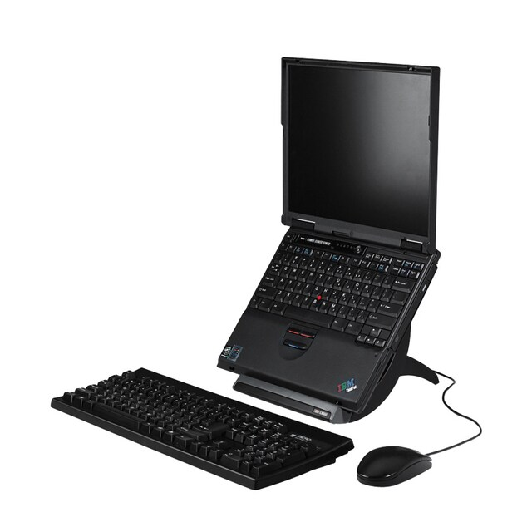
- Sit with your upper legs at approximately 90° to your body. Use a cushion to raise your body if your chair is too low.
- If using a laptop, use a separate keyboard and mouse (right), so you do not need to hunch over the integrated keyboard.
- Use a laptop riser (right), or other sturdy items (e.g. books or boxes) to raise your laptop so that your eyes are roughly level with the top of the screen.
- Clear the area around you of unnecessary items so that you can freely move your legs, arms, and easily access the equipment and materials that you need.
- Sit upright and close to the desk so your arm does not need to be outstretched to use your mouse.
- Try to leave a clear space in front of your keyboard on which you can rest your wrists and forearms.

Prolonged use of computer equipment can also lead to eye strain and fatigue, especially when using laptops, which tend to have smaller screens. The following measures can help to reduce these risks:

- Position your screen so that it is free of glare from windows and lights.
- Adjust the brightness and contrast of your screen to suit the lighting conditions of the room.
- Adjust the zoom setting of your screen by holding Ctrl and using your mouse scroller to zoom in and out. Set the screen so that you can easily read text without having to squint or move closer to the screen.
- Take breaks away from your screen every 30-60 minutes. Use this time to stand up, move around and stretch.
- If possible, stand up to make phone calls or read documents that are not on your computer. Create a habit of taking every opportunity to move away from your screen to complete tasks.

Although your workstation may not be ideal, taking the above measures will help to ensure that you can work comfortably and productively during this time.

The Mental Impact of Working from Home

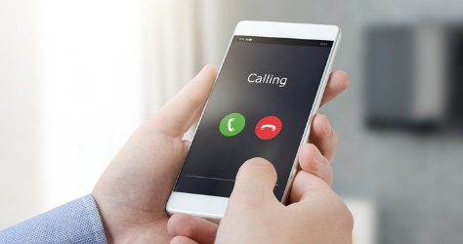
Communication: As well as having an impact on your body, working from home may also affect you mentally. For many people the workplace is where they have most social interactions, and for some it may be their only regular form of social contact. Working from home may therefore lead to feelings of isolation and loneliness, particularly when social distancing measures means that you may not be socialising with friends outside of work. It is therefore important to maintain contact with colleagues through other means, whether by phone, video calls or online messaging apps. Be proactive in contacting colleagues and do not feel that you should only discuss work related matters, it is likely that you would have non-work conversations with colleagues in your normal workplace and working from home should be no different.

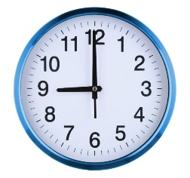
Routine: It is important to maintain a structure to your working day to aid focus, avoid procrastination, prevent over scheduling and maintain a sense of normality. Try to keep to a regular work schedule with a set start and finish time and take breaks at the times that you would in your normal workplace. If you would normally make a hot drink and catch up with a colleague in the office at 10.30am, pop the kettle on and pick up the phone.

Work-Life Balance: Working from home can greatly improve work-life balance by creating extra time at the start and end of each day that would normally be spent commuting. However, it can also make it difficult to separate your work life from your home life. The use of mobile phones and laptops means that it can be difficult to switch off from your work, but it is important to keep your work and your home life separate. As mentioned above, having a routine is key. Decide what your working hours will be and try to stick to them. If possible, at the end of the day put your work phone and equipment away and do not be tempted to check your work emails or messages late in the evening.

Get the Facts: In what is already a worrying time, false information and hearsay can lead to undue stress and concern. Equip yourself with the facts. GOV.UK, Health Protection Scotland and Public Health Wales are good sources of up to date and accurate information about COVID-19. As many companies are facing a period of uncertainty you may also hear rumours about the future of your employer or potential changes to your work. Once again, it is important to establish the facts and avoid hearsay. Speak to your manager about any concerns you may have.

Speak Up: If you feel that you are struggling, speak to your manager, or if applicable, your HR department. Your employer has a responsibility for your health, safety and welfare at work, including your mental wellbeing, and this applies equally when you are working from home. If you are finding it difficult to cope with social isolation, new methods of working, your workload, or even a lack of work, it is important that you speak up at an early stage. Do not wait until you feel unwell to raise concerns.

Keep Active: As well as the obvious physical benefits of keeping active, taking regular exercise has been shown to reduce stress, alleviate anxiety and improve general mental wellbeing. There are additional benefits to taking exercise outdoors (e.g. walking, jogging, cycling). As a minimum, aim for at least one brisk walk in fresh air per day, and make sure that you abide by the Government’s guidance on social distancing. If it’s not possible for you to be active outdoors, there are many free online resources to help you exercise indoors, including video-based workouts and exercise classes.

Know how to Access Support Services: Your employer should have procedures in place to assist employees who are struggling to cope. This may include access to confidential helplines, counsellors or occupational health specialists. For smaller companies it may simply be a case of speaking to a senior manager who can make a referral to a specialist provider if required. Find out what support is available to you and know how to access it.

