What is Display Screen Equipment (DSE)?

Display screen equipment (DSE) is any work equipment that has a screen that displays information, such as computer screens (either desk based or laptops), tablets and smart phones.

Who are DSE Users?

A DSE user is defined as a person who, in connection with work,
- normally uses DSE for continuous or near-continuous spells of an hour or more at a time;
- uses DSE in this way more or less daily;
- has to transfer information quickly to or from the DSE;

and also need to:
- apply high levels of attention and concentration; or
- are highly dependent on DSE or have little choice about using it; or
- need particular training or skills to use the DSE.

DSE Assessments

The Health and Safety (Display Screen Equipment) Regulations 1992 (amended 2002) requires all employers to carry out a ‘suitable and sufficient’ risk assessment for workstations which are used by persons they employ who fall under the category of a DSE user. The aim is to identify the hazards and evaluate the risks to the user and subsequently reduce any risks to the lowest extent reasonably practicable. This is a requirement of employers regardless of who has provided the equipment.

What are the health risks associated with DSE?

Some DSE users can suffer from fatigue, eye strain, upper limb problems and backache. These problems can be caused by overuse or improper use of the DSE, poorly designed workstations or work environments, incorrect or a lack of eye wear, or poor posture.

How to control the risks of using DSE

Getting the Right Sitting Position

Firstly,

- Pull your chair away from your workstation.
- Remove any coats, scarves etc. from the back of your chair.
- Check your chair to see how you can adjust the height, seat pan, angle of the chair back etc.

Then,

- Adjust your chair and monitor so that they are in a comfortable position for your work.
- Raise the seat pan until your pelvis is slightly higher than the knee. Ensure that your feet are still flat on the floor. Use a footrest if your feet do not touch the ground. This will avoid excess pressure from the edge of your seat on the backs of your legs and knees.
- Ensure that your chair is adjusted to support the small of your back. If the chair has a lumbar support, ensure that this is positioned in the lower back.
- Sit upright and do not slouch.
- Sit looking straight on at the monitor. Avoid twisting your upper body by using the swivel mechanism on your desk chair.

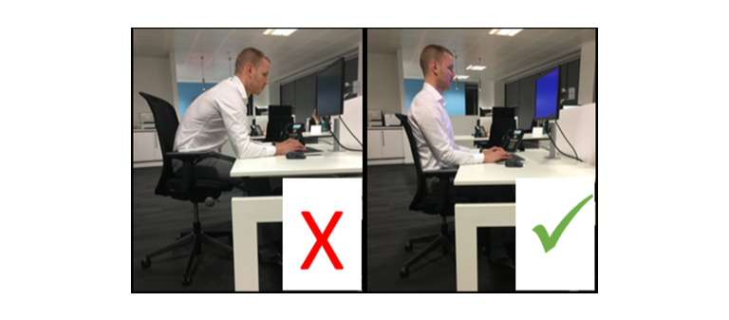

- Forearms should be approximately horizontal and the user’s eyes should be the same height as the top of the screen.

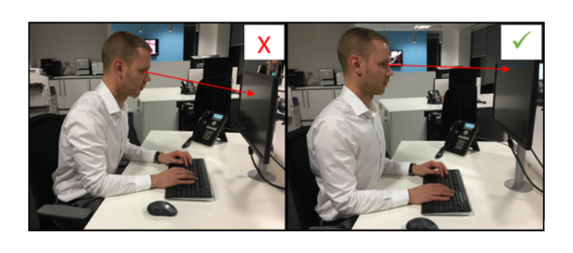

Workstation set-up and use

- Your workstation should be tidy and not cluttered.
- There should be sufficient space for your documents and work equipment.
- Ensure that boxes, bags, bins etc. are not stored beneath your desk, as this will restrict your leg movement.
- If possible, sit symmetrical to your monitor.
- Position your monitor to avoid glare or reflections (or adjust window blinds). The monitor should be placed at a 90º angle to any windows or overhead lights.
- Where blinds are in place, use these to stop glare and reflection.
- Adjust the brightness and contrast controls on the screen so that you can clearly read the screen (controls can usually be found on the side of or underneath your monitor).

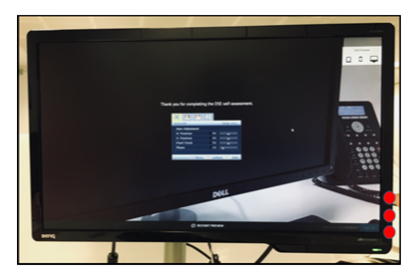

- Place frequently used items such as your keyboard, mouse and phone in easy reach, so that you are not stretching to reach them.
- Keep the mouse close to you so that you do not have to stretch to use it, and so it can be used with the wrist straight and support your forearm on the desk. Do not grip the mouse too tightly.

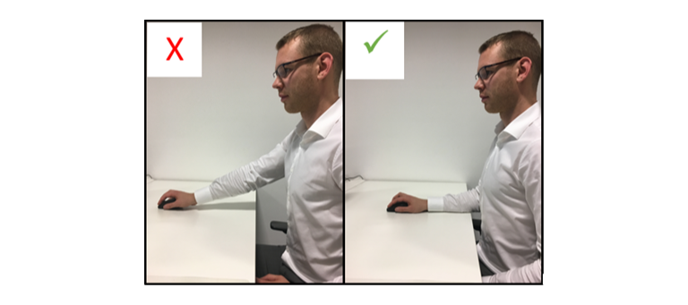

- Your keyboard should ideally be adjusted so that it is flat on the surface of the desk, this will help you to adopt a more neutral (straight) position in your hand and wrist when typing. Keep your elbows close to your body when typing.
- When using the phone and either typing / writing, ensure you hold the phone with your non-typing / writing hand. If you use your phone on a regular basis, then you may benefit from a headset.
- Take regular breaks from using the DSE. A short screen break of 5 minutes every hour to complete non DSE tasks.
- If your job role involves reading off sheets of paper regularly, a document holder will be useful. This should be placed between your keyboard and your monitor.

Using a laptop

- Either use a docking station and work from a separate desktop monitor, keyboard and mouse, or place your laptop on a laptop stand and work from a separate keyboard and mouse.

Eye and eyesight tests

- DSE users or those who are going to become DSE users should be provided with an appropriate eye and eyesight test to be carried out by a competent person, if requested.
- Employers must provide their employees with special corrective appliances for the work being done by the DSE user when normal corrective appliances cannot be used and when the result of any eye and eyesight test shows such provision to be necessary.

Disclaimer

These example forms, checklists and model policies are provided by Hettle Andrews for general guidance on matters of interest. In making these documents available to a general and diverse audience it is not possible to anticipate the requirements or the hazards of any subscriber’s business. Users are therefore advised to carefully evaluate the contents and adapt the forms and checklists to suit the requirements of each situation. Hettle Andrews does not accept any liability whatsoever for injury, damage or other losses which may arise from reliance on this information and the use of these documents.

Copyright of these documents remains with Hettle Andrews and whilst subscribers are permitted to make use of them for their own purposes, permission is not granted for resale of the intellectual property to third parties.

