Company Name
Location
Method Statement Title
Description of Work
This Method Statement has been developed and must be read with the following Risk Assessments:
Risk Assessment Reference |  |  | Title
Work Commences on
Areas covered
Duration of Work (actual or estimated)
Number of Workers
Personnel (include details of all personnel involved in the task and any specific training, skills or qualifications required)
Name |  |  | Position |  |  |  | Competence Details
Emergency arrangement details (tick all that apply)
Fire/evacuation |  | First Aid |  |  | Pollution/spill |  |  | Other
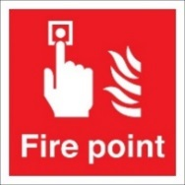 |  | 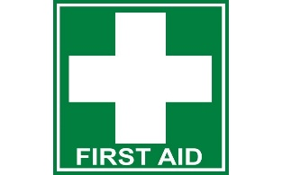 |  |  | 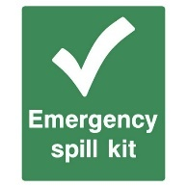
Personal protective equipment (PPE) requirements (tick all that apply)
 | 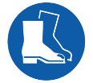 |  |  |  |  |  | 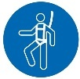
Head  (EN 397) | Foot  (BS EN 345-1) | Hi-vis Vest | Hand  (BS-EN 388) | Eye  (EN166) |  | Hearing  (EN 352-1) | Fall Arrest | Other | Other
Construction dust (Note: construction dust is harmful and can lead to fatal lung diseases such as silicosis)
Will the work create dust or fumes? |  |  |  |  |  |  |  | Yes | No
Identify specific control measures to avoid or minimise dust or fumes
Identify suitable respiratory protective equipment (RPE) that will be required if dust or fumes cannot be avoided

Hazardous materials
Are hazardous materials to be used? |  | Yes |  | No
Attach or identify specific controls required from COSHH risk assessments
Permit required (tick all that aply)
 | Permit to Work (general) |  | Permit to enter  (confined spaces) |  |  | Permit to Dig
 | Hot-Work Permit |  | Out of hours permit |  |  | Other
Details of person issuing permit
Description of safe method of work
Where appropriate include information such as sketches, details of significant risk controls, sequence of works, etc:

Tools, plant and equipment
Type |  |  |  | Details of inspections/test certificates
Briefing register
A copy of this briefing register must be attached to the method statement, together with other relevant information (such as the associated risk assessments, permits, and/or COSHH assessments).

Supervisor in charge of work
I confirm that I have read and understand the requirements of this method statement and associated risk assessments and have communicated them to operatives under my control, and to those who may be affected by its requirements.

Note: it is important that you test the operatives understanding and assume that have read and understood the method statement and risk assessments.

Name |  |  | Position
Signature |  |  | Date
Operatives/workforce carrying out the work
I understand and will agree to adhere to the contents of this method statement and the associated risk assessments. I have attended a site induction/briefing that explained the general site rules and necessary site specific arrangements.
Name |  | Position | Signature |  | Date

If you have any doubt about information given or contained in this method statement – please ask.

